**INDIAN JUDICIARY AND TECHNOLOGY**

The Judiciary is one of the institutions on which the noble edifice of democracy and rule of law of India rests. The judiciary stands as a bulwark against abuse, misuse or excess of power on the part of the executive and protects the citizens against governmental lawlessness. Judiciary is one of three basic organs of the foundation of the State.

**Stakeholders in Courts:**

1. Judges

2. Litigants

3. Lawyers

4. Court Staff

5. General Public

6. Government

People have a stereo-typed view about Indian Courts being slow, rigid and secretive. With the help of IT, it can be changed and Courts can become more efficient, fast, responsible. IT is available for various uses in the Indian Judiciary and allied areas and, it is already in operation in some Courts.

**AREAS WHERE IT IS ALREADY IN USE IN INDIAN JUDICIARY:**

**VIDEO-CONFERENCING:**

The court is connected to the Jail by ISDN Lines. At both ends, a camera unit and a display unit like a 29" TV Screen is provided with a recording facility at the Court's end. Under-trial is produced at the Jail end. The Judge, Lawyers and witnesses etc. remain present in the Court. The judicial remand of the under-trial can also be extended without him being physically present in court.

Benefits

* Dreaded criminals can be tried without any risk.
* Cost in producing undertrials only for remand extension can be saved.
* Multiple trials of an accused lodged in one jail is possible in different states of India.

**DATA MANAGEMENT:**

Data can be captured at the filing stage for the new cases. Data of previous cases are fed in computers using dedicated manpower. Data related to the date of filing, a full description of parties, law provision invoked, property no., stage of the trial, next date of hearing and advocate's name etc. Data is updated on daily basis without fail.

Benefits

* Cause-lists can be generated at the press of the button.
* Periodical statements can be easily generated.
* Age-wise / category-wise segregation of cases is possible.

**DIGITAL SIGNATURES:**

The data to be sent through internet/e-mail is encrypted by using the digital signature card provided by the Service Provider. The said data is then sent to the receiver through e-mail/internet in an encrypted format. The receiver decrypts the data by using the verifier software provided by the Service Provider.

Benefits

* Release warrants can be sent from Courts to Jails within minutes of the passing of the order.
* Certified copies can be immediately issued by the copying branch as soon as the order is digitally signed.

**BIOMETRIC IDENTIFICATION:**

Biometric Readers are available in the market which can be installed with Court Computers. Biometric Profiles of the accused, sureties, witnesses and other Court users are to be prepared and kept in an online Data-bank. A person has to put his finger on the Biometric Reader to identify him/her and his/her entire history can be retrieved.

Benefits

* The accused, who give a different name at the time of his subsequent arrest can be easily identified.
* Stock witnesses who are in the habit of giving evidence in many cases can be pinpointed.

**E-COURTS:**

Paper-less Courts with audio-visual presentation and Video-conferencing facility. Automatic recording of evidence. Modelled on the pattern of Court-21 of USA. Existing files- Scan & OCR Software to be used.

Benefits

* Immediate retrieval of the record is possible.
* Physical Barriers are broken.
* Visual animations & presentation of Arguments.

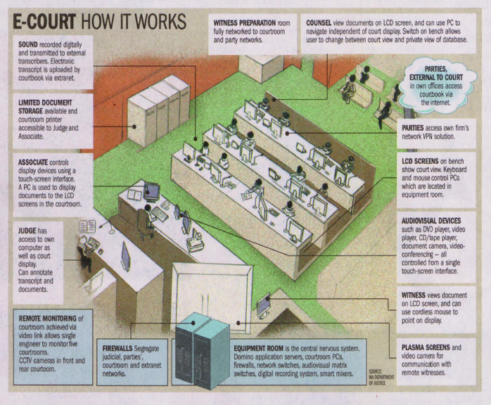

E-courts proved to be very effective in the lockdown; many pending cases are heard through this. E-filing is the first step towards E-court. Recently Justice D.Y. Chandrachud said, “The idea is to show the flexibility of the Indian Judicial system. Not for a moment do we want to replace the physical hearing. But we are conscious of the need to protect the public health of our lawyers, litigants who come to our country or across the country.”

Recently, SA Bobde, the Chief Justice of India said that the Supreme Court has proposed to introduce a system of AI that would help in better administration of justice delivery. Some other ways technology can impact Judiciary:-

**ARTIFICIAL INTELLIGENCE:**

AI is capable of assisting judges by predicting the vital information regarding an ongoing case based on past cases of a similar nature.

#### ****SPEECH RECOGNITION:****

#### **As India is a multi-lingual country,** Speech recognition will help in improving the productivity of the Judiciary and corporate legal departments by supporting tasks such as streamline documentation efforts.

#### ****BLOCKCHAIN:****

#### If we talk about blockchain then it is a time-stamped series of immutable records of data that is managed by a cluster of computers not owned by any single entity****.**** Blockchain will help in addressing at least three chronic challenges in court recordkeeping that are: managing court judgments, warrants, and criminal histories.

#### CONCLUSION:

#### As long as people won’t get justice on time there is no meaning of “JUSTICE, social, economic and political” mentioned in our preamble. It needs to be monitored continuously. Technology can allow courts to adapt more quickly to changes in laws, society and demographics by taking advantage of configurable platforms and workflows.